Factory and Head Office: Zip 156013 Russia, Kostroma reg, Kostroma, Galichskaya str, 136 a, KOSTROMA BOILER EQUIPMENT PLANT LLC tel: + 7-910-801-54-50 (We speak English) Email: dmitry-mrs@mail.ru Web: http://ecokzko.ru/en/

Price List for Waste Neutralization Plants:

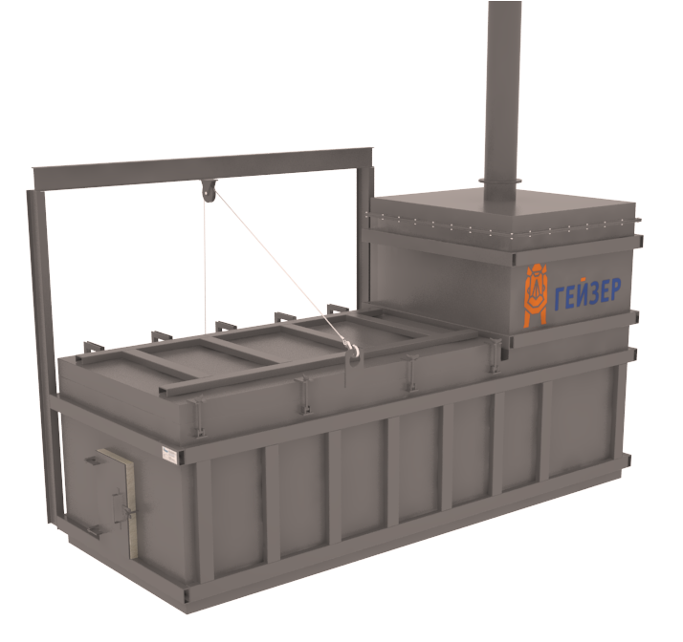Incinerators:
Geyzer^{ТМ} incinerators for domestic, industrial and medical waste are high-tech furnaces specially designed for controlled combustion of domestic, industrial and medical waste. These plants are capable of destroying more than 2,000 types of waste of various hazard classes. As the world practice showed, incineration is the most profitable, environmentally friendly and affordable way to neutralize waste in the places of their formation.
Geyzer^{ТМ} incinerators for domestic, industrial and medical waste are designed taking into consideration the strict environmental requirements of the EU. They are ideally suited for enterprises operating municipal consumption wastes, industrial enterprises with a large number of production wastes, remote settlements and other places of local residence of people, as well as for all enterprises where production and consumption wastes are generated and which are prohibited or economically unprofitable to dispose (neutralize) in other ways.
Geyzer^{ТМ} incinerators of domestic and industrial waste completely solve the problems of handling hazardous and non-hazardous waste. In addition, they allow saving significant amounts of money for disposal.
Model | Loading volume, kg | Incineration rate, kg/hr | Plant weight, kg | Retail price, $
 |  |  |  | Diesel | Gas
Incinerator Geyzer-100 | 100 | 50-70 | 1,400 | 4,284 | 5,401
Incinerator Geyzer-200 | 200 | 50-100 | 1,700 | 4,835 | 5,966
Incinerator Geyzer-300 | 300 | 50-100 | 1,800 | 5,811 | 6,942
Incinerator Geyzer-400 | 400 | 60-110 | 2,000 | 6,800 | 8,087
Incinerator Geyzer-500 | 500 | 60-110 | 2,250 | 7,946 | 9,487
Incinerator Geyzer-750 | 750 | 80-150 | 4,000 | 12,540 | 13,940
Incinerator Geyzer-1000 | 1,000 | 150-250 | 4,400 | 18,761 | 20,599
Incinerator Geyzer-1500 | 1,500 | 250-300 | 4,800 | 22,154 | 23,992
Incinerator Geyzer-2000 | 2,000 | 250-350 | 8,000 | 28,233 | 31,061
Incinerator Geyzer-3000 | 3,000 | 250-400 | 10,000 | 43 785 | 46,613
Delivery set: Lamborghini burners (Italy) (depending on the choice of model: gas/diesel), gas afterburner, winch for the hatch of the loading chamber, automation kit and operating manual.

By purchasing our products you receive the following undeniable advantages:
- A quality product that simply and quickly solves all your waste problems.
- Long service life of the equipment due to the clever design and use of high-quality materials.
- Low cost due to low cost of resources in Russia, successful design decisions and reasonable price policy of the manufacturer.
- Delivery to the place of installation anywhere in the world.
- Assistance in the installation, commissioning and training of personnel.
- Assistance in after-sales service and repair.
- Free expert advice at any time when a problem occurs.
Incinerators GeyserTM complies with Directive 2000/76/EC of the European Parliament and of the Council of 4 December 2000 on the incineration of waste, so they can be installed in the EU.

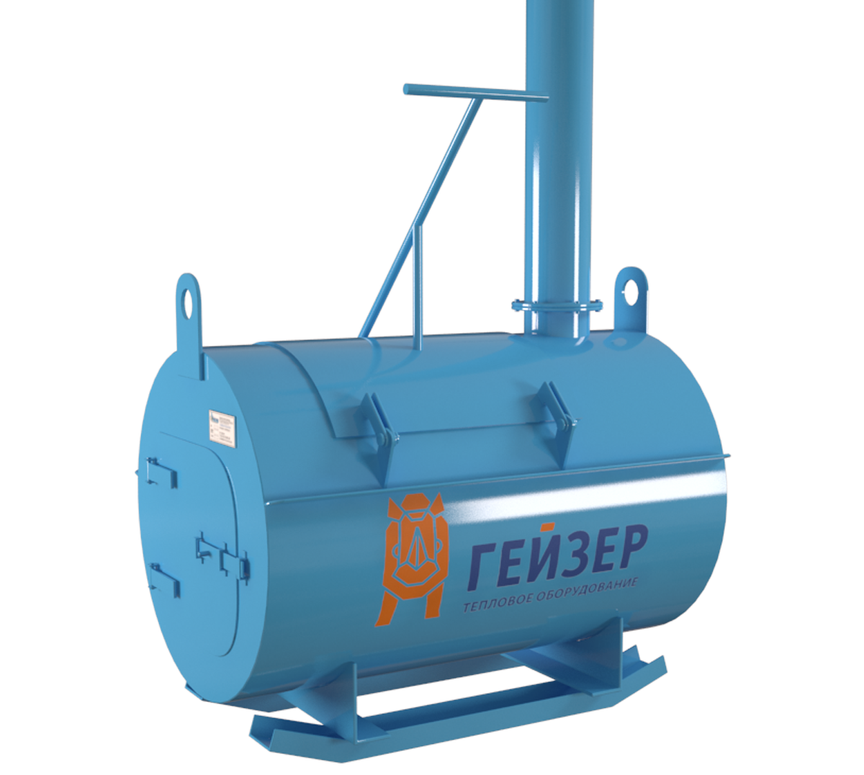Cremators:

Geyzer^{ТМ} cremators of biological waste are special furnaces for incineration of biological waste. These wastes are considered hazardous and prohibited to be buried (placed on landfills), so incineration is practically a non-alternative way to neutralize them.
Incineration of biological waste does not pollute the atmosphere, so the cremators consist of one chamber, they are simpler, more economical and cheaper than incinerators. Nevertheless, the use of Geyzer^{ТМ} biological waste cremators easily solves the problem of neutralizing biological waste by incineration in agricultural enterprises (especially in cattle breeding and poultry farming), in veterinary clinics, and in various meat processing enterprises.
Our company manufactures a wide range of Geyzer^{ТМ} biological waste cremators of various capacities to flexibly tailor the typical solution to the specific needs of the consumer. After purchasing the equipment, we will deliver it to the installation site, help connecting it and train the personnel.
Model* | Loading volume, kg | Incineration rate, kg/hr | Plant weight, kg | Retail price, $.
 |  |  |  | Diesel | Gas
Cremator Geyzer CR-50 | 50 | 25-35 | 300 | 1131 | 1,697
Cremator Geyzer CR-100 | 100 | 35-50 | 700 | 2262 | 2,757
Cremator Geyzer CR-200 | 200 | 35-50 | 970 | 2545 | 3,110
Cremator Geyzer CR-300 | 300 | 35-50 | 1800 | 3110 | 3,534
Cremator Geyzer CR-400 | 400 | 40-55 | 2350 | 3676 | 4,807
Cremator Geyzer CR-500 | 500 | 50-70 | 2600 | 4524 | 5,372
Cremator Geyzer CR-1000 | 1000 | 60-100 | 4000 | 6574 | 7,705
Cremator Geyzer CR-1500 | 1500 | 75-110 | 6500 | 7705 | 9,402
Delivery set: Lamborghini burners (Italy) (depending on the choice of model: gas/diesel), gas afterburner, winch for the hatch of the loading chamber, automation kit and operating manual.
* A chamber of additional afterburning of flue gases for all models of Cremators:
- on diesel fuel: $920;
- on gas: $1,340.

You can be sure that Geyzer^{ТМ} equipment will quickly, efficiently and inexpensively solve your problems with any waste.

Director Tatyana Platonova

